**Uploading files in Selenium**

Selenium is unable to access windows components and it can be handled through AutoIT. AutoIt is a freeware BASIC-like scripting language designed for automating the Windows GUI and general scripting. It uses a combination of simulated keystrokes, mouse movement and window/control manipulation in order to automate tasks in a way not possible or reliable with other languages (e.g. VBScript and SendKeys).

You can get more information in the URL: <http://www.autoitscript.com/site/>

**Download**

You can download AutoIt from the URL : <http://www.autoitscript.com/site/autoit/downloads/>

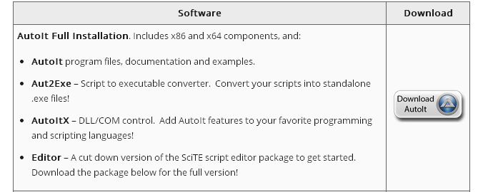

**AutoIt Documentation**

The AutoIt documentation is present in the URL: <http://www.autoitscript.com/autoit3/docs/>. The important stuff in the documentation is

1. Using AutoIt -> AutoIt Window Info Tool (AU3Info) - <http://www.autoitscript.com/autoit3/docs/intro/au3spy.htm> . This tool is helpful in getting the information of the window to be automated.
2. Tutorials-> [My First Script (Hello World)](http://www.autoitscript.com/autoit3/docs/tutorials/helloworld/helloworld.htm) (<http://www.autoitscript.com/autoit3/docs/tutorials/helloworld/helloworld.htm>) and Tutorials-> [Simple Notepad Automation](http://www.autoitscript.com/autoit3/docs/tutorials/notepad/notepad.htm) (<http://www.autoitscript.com/autoit3/docs/tutorials/notepad/notepad.htm>) . These give a basic understanding of automation with AutoIt.

**AutoIt in testSeleniumFramework Project**

We have used AutoIT for xml file import while creating an asset in dash. The aut and exe scipts (OpenDialogHandler.au3, OpenDialogHandler.exe) are in the resources folder (C:\Projects\testSeleniumFramework\src\test\resources). The function **dashuploadfile** has the code to call the OpenDialogHandler.exe file, which performs the given input file upload. Right now the OpenDialogHandler is handled for IE and firefox browsers.